Log Analyzer
1. Scenario – Positive flow
Given the format of the input is .log
When user uploads the file
Then input file should get uploaded.
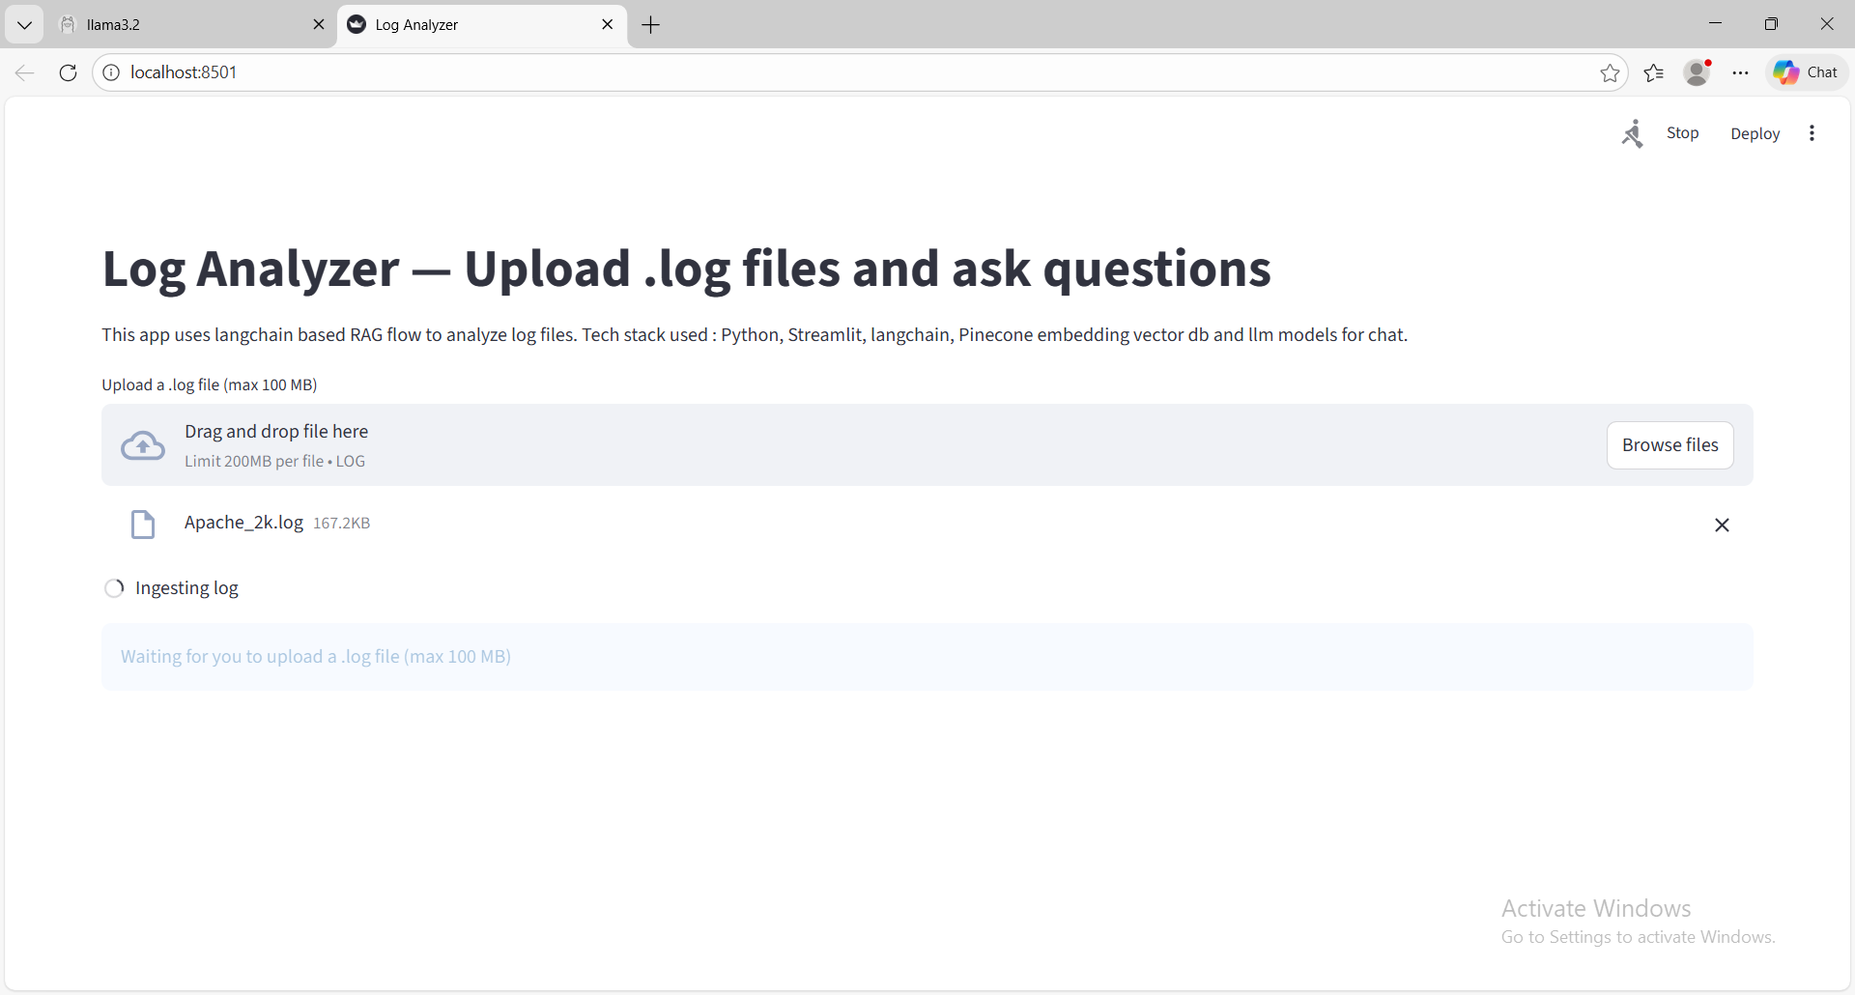
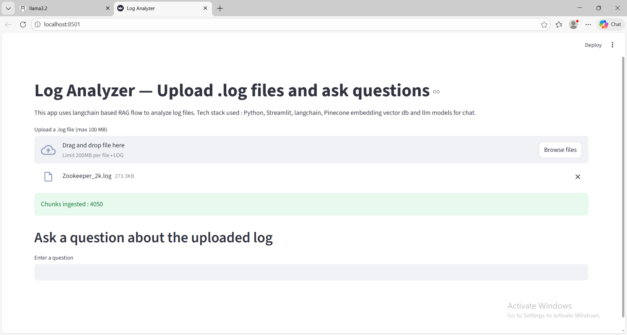
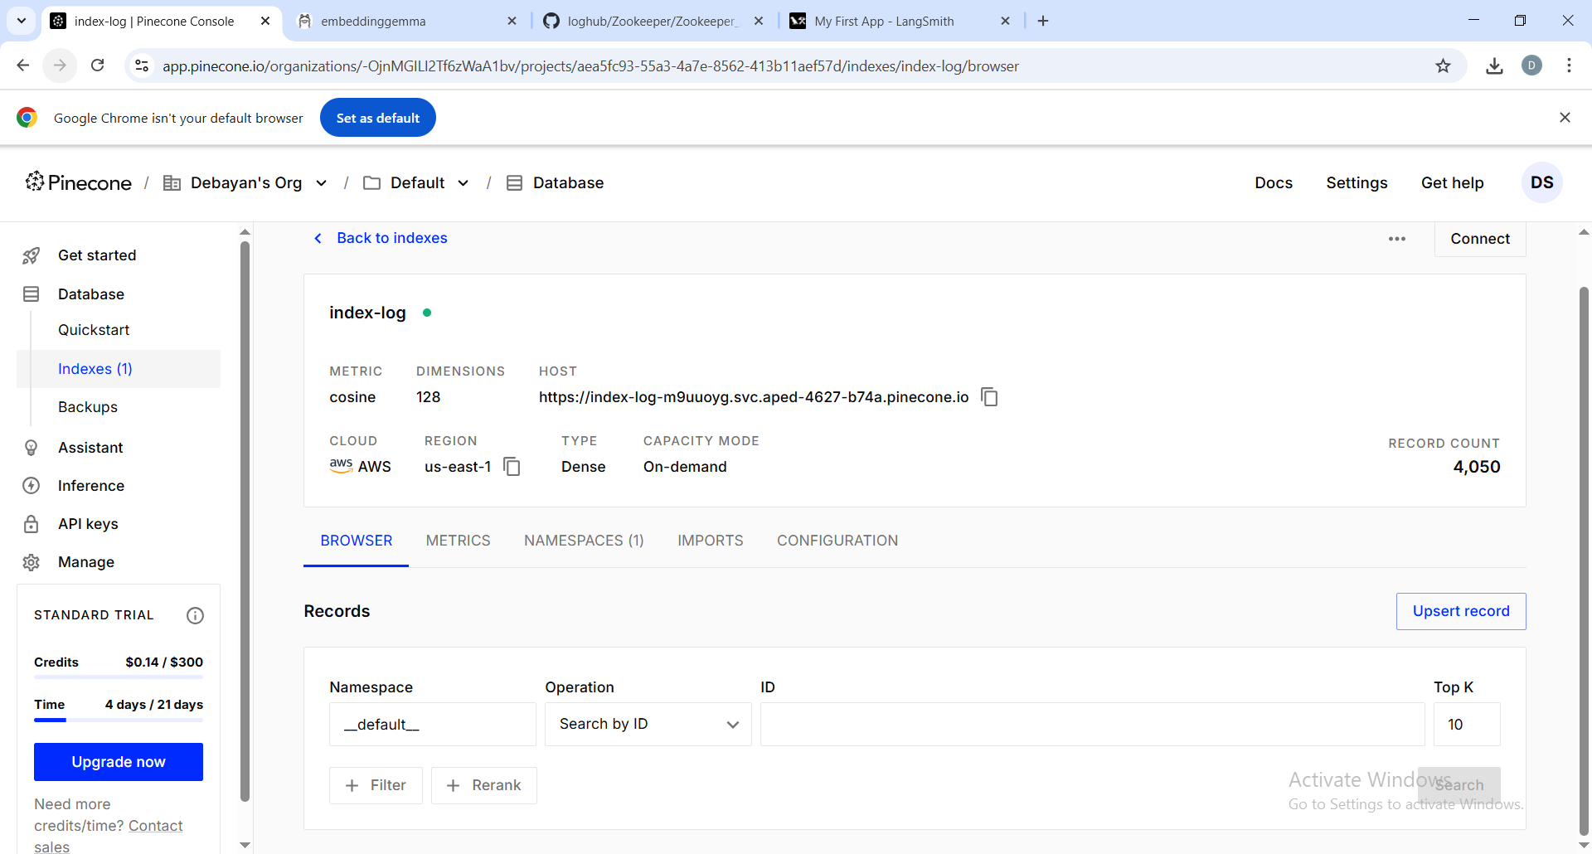

2. Scenario – Positive flow
Given the log file
When user inputs a prompt to list top 3 issues
Then no of times a issue is occurred is greater than 5, greater than 3, greater than 2, use emojis to indicate it.
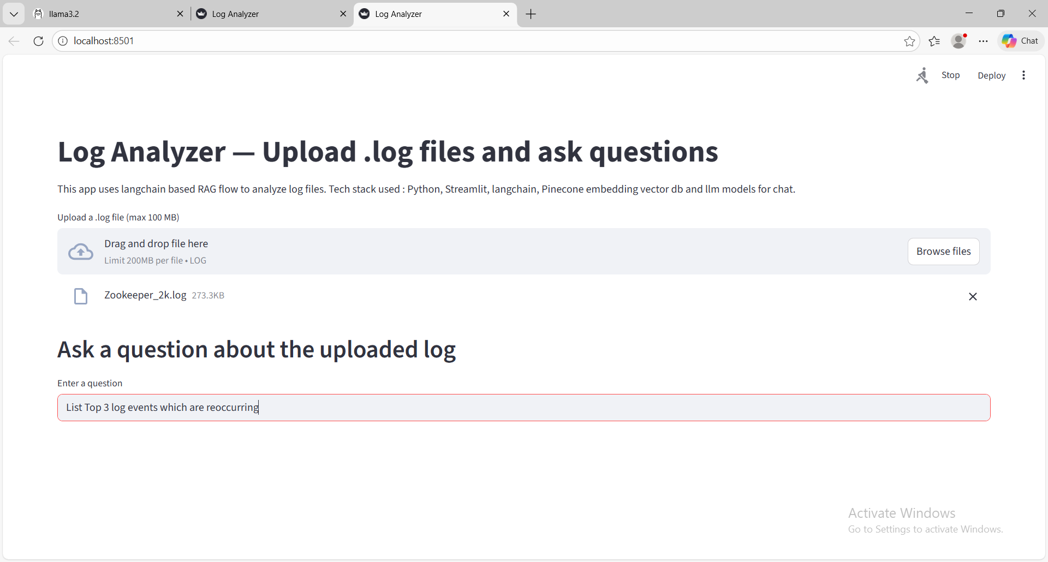
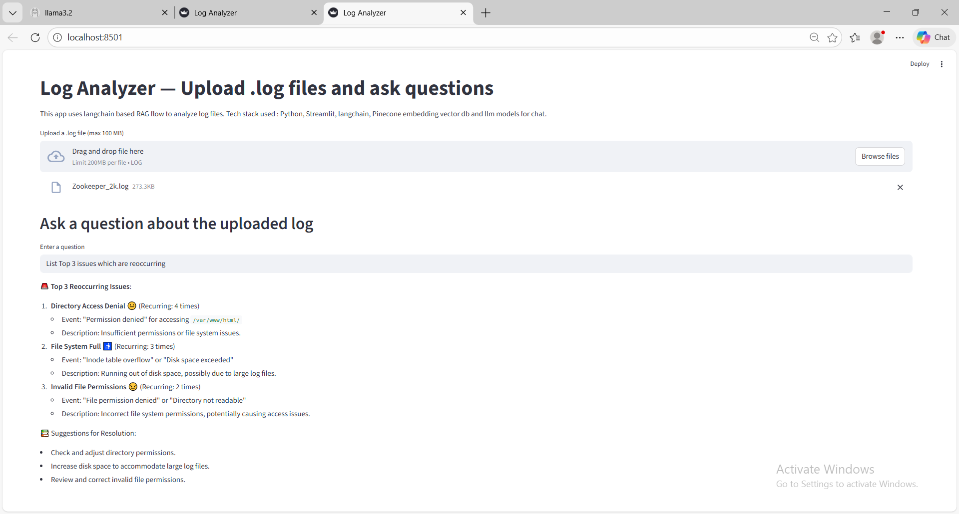

3. Scenario – Error Handling-1
Given the format of the input file is not .log
when user uploads the same,
Then the upload should be failed
AND respective error message like ‘Upload only valid file format’ should be displayed.
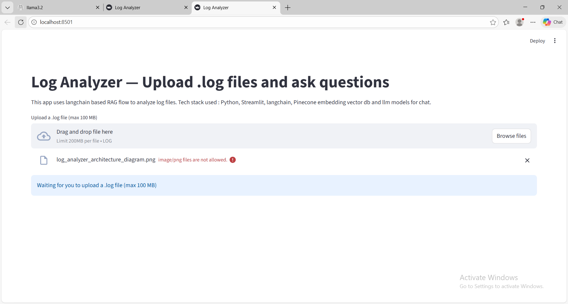
4. Scenario – Error Handling-2
Given the size of the file is not within the prescribed limit
when user uploads the same,
Then the upload should be failed
